Tick Tock
Patient Name: Stephanie Hilltop
Patient Identifier: PRXGE123129231  Patient Date of Birth: 3/18/1982  Weight: 120 lbs.  Body Temperature: 99.5 F | Blood Pressure: 130/85  Respiration Rate: 15 breaths per minute  Pulse: 75

Stephanie Hilltop is a 35-year old female from Lafayette, Indiana. She came into the IU Arnett Urgent Care Center and showed the nurse a red area under her left arm and a small tick in Tupperware container. The tick looked very much like a deer tick.
After you enter the exam room, Stephanie tells you, “I just noticed the tick this morning. We looked on WebMD to figure out how to remove it, and my husband tweezered it out of there. Later in the day, this red spot appears red spot, so I wanted to see if we did it wrong. I know sometimes you don’t get the head out. Maybe it’s infected.”
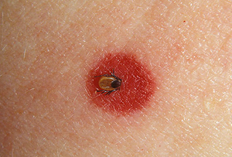
During the interview, you ask her when she might have been bitten.
“We were up in Michigan for a few days with our dogs. So, it could have bitten me any time. But, I think I would have noticed it. We don’t have a shower up at our cabin, but I take a cat bath every morning. I doubt I would have missed a tick under my arm for three days. Maybe one day, but that’s it.”
You’re a bit concerned about the area of redness that has developed. You ask her if it’s bothering her.
“It itches real bad, like the worst mosquito bite I’ve ever had.”
You ask her if she feels tired or stiff.
She says, “A little, but that’s pretty normal after one of our weekends in Michigan. We’re up late talking, and the cots we sleep in aren’t really comfortable.”
As you examine her, you ask whether she feels weakness in her arms and legs.
Now Stephanie starts to look worried. “Not really. Hey, is this something serious?”
You tell her tick bites are usually not a big deal, but you just want to make sure everything is all right.
You look at Stephanie’s file on your laptop. She seems like a typically healthy 35-year old female. She’s had the flu a few years ago and needed to be rehydrated. She fell off her bike last summer and sprained her wrist pretty bad. She is highly allergic to cats but apparently not dogs. Otherwise, everything looks fine.
Her vitals do seem a bit elevated. Her body temperature is a bit high, and her blood pressure and respiration rate are slightly elevated. Her pulse is about the same as in the past.
How would you fill out the SOAP note?

Just a Bit Over the Top
Patient Name: Jim Hampton
Patient Identifier: Temp SGEG 192938E  Patient Date of Birth: 7/25/1957  Weight: 250 lbs.  Body Temperature: 98.4 | Blood Pressure: 160/100  Respiration Rate: 20 breaths per minute  Pulse: 85

Jim is 60-year old male from Frankfort, Indiana. Recently, his son, Evan, brought him into the St. Elizabeth East Emergency Room. Jim was shingling a roof in Lafayette, when he suddenly felt faint and stumbled. He hit his head on the chimney. A safety rope kept him from tumbling off the roof.
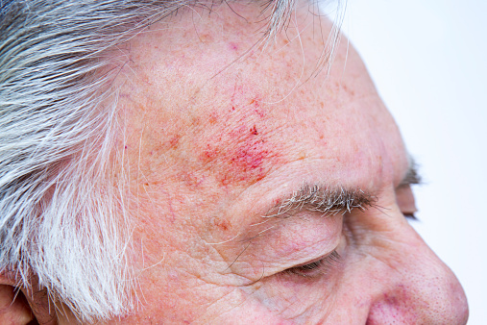
As you walk in the door, the nurse tells you that there is no prior information on Jim in the computer and that he’s already eager to leave. She tells you, “He says he feels better, and is ready to go back to work. I asked him to wait, so you can take a look at him before he’s on his way.”
As you look Jim over, he looks all right. He has a scrape and a bruise on his forehead where he hit the chimney. He seems a bit pale.
You pinch the skin on his forearm and it takes a few moments to melt back into the arm. He may be a bit dehydrated, but he’s been drinking Gatorade since he stumbled.
You check his eyes for concussion, and he passes. Everything looks normal. His pupils respond correctly, and they are straight. He is able to read the eye chart at a typical level for a man his age.
Jim says, “Hey, thanks for looking me over, but I feel fine. I really want to finish that roof by tomorrow.”
You point out that his blood pressure is pretty high and ask him if that’s normal for him.
“Well, it’s been a long time since I’ve seen a doctor. When I went some years ago at the Veterans Hospital, they told me my blood pressure was high and that I might need to do something about it.”
You’re concerned about him getting back on the roof today, so you tell him he should take the rest of the day off to rest.
“I’ll think about it, but there’s rain in the forecast tomorrow. We need to get this thing done.”
You tell Jim to stop by the desk on the way out of the Emergency Room.
While he’s talking to the staff at the desk, his son pulls you aside. “Dad hates going to the doctor. We only brought him in here because he was stumbling around after we got him off the roof. He was really sweating, so we threw some water on him. We forced him to down a bottle of Gatorade.”
You tell Jim’s son that you’re concerned about him getting back on the roof today. You tell him he should insist his dad not climb around on a roof. Plus, you point out that his blood pressure needs to be checked out.
His son laughs, “Yeah, good luck with that. Dad can be kind of stubborn. My guess is that he’s not going to do anything until he has a real health scare.”
You tell Jim and his son that you would like to call later to check on him. Jim says that’s fine as he heads out the door. His son thanks you and says, “I’m actually worried about him. He definitely won’t listen to me but he might listen to you. So call.”
How would you write up this SOAP note?

Not Sure What to Think
Patient Name: Maria Vasquez
Patient Identifier: PUID 2915693  Patient Date of Birth: 10/12/1997  Weight: 110 lbs.  Body Temperature: Not Taken | Blood Pressure: 100/70  Respiration Rate: 15 breaths per minute  Pulse: 70

Maria is a 20-year old college student who was brought into PUSH at 4:00 pm on Saturday. Her friends carried her into the waiting room because she was having trouble walking and was slurring her speech.
Outside the exam room, the nurse stops you and says, “Looks like someone had a bit too much to drink today. Her friend says they were over at a guy’s apartment drinking a few beers and watching a movie. She seems pretty wasted.”
You walk in the room and Maria is vomiting in a tub. Her friend, Jacob, is helping her sit upright. He looks very concerned.
Jacob turns to you and says, “This is really weird. If she even had more than one beer, I would be shocked. We were just hanging out watching the Boiler game.”
Maria looks up but is having trouble focusing on you. She seems to want to talk, but she is hard to understand. You give her a quick exam and you decide she’s all right for the moment. You ask the nurse to set up an ambulance to take Maria over to IU Arnett Urgent Care.
You ask Jacob if he was with her the whole time.
“No, I ran for pizza. When I got back, I saw her slumped over on a chair in the corner of the room. That’s not normal for Maria. She’s a real lightweight with alcohol, so she usually just sips a beer to be social. No one in the apartment noticed she was in bad shape. That really pisses me off.”
You look at her records, and everything seems normal. She had strep throat last year. She carries an EpiPen in for her peanut allergy but her records don’t say whether she has ever used it. She’s not presenting the usual symptoms of an allergic reaction anyway.

You begin to suspect someone slipped Maria some Rohypnol. She’s presenting all the typical symptoms, but you don’t want to say anything to Jacob. You call the nurse and ask Jacob to wait out in the waiting room.

As he walks out the door, he asks, “You don’t need to call the cops, do you? I mean, we’re underage, so I know we shouldn’t be drinking. That poster on campus says ‘just make the call,’ so I did. I brought her in, but I don’t want her to get in trouble.”

You assure Jacob that he did the right thing and tell him to stick around in case Maria needs his help.

How would you write up this SOAP note?

